|  |
| --- |
| DooHee |
| [Type the document title] |
| **[CRAZZT SHOOTING]** |
| Version #1.3  All work Copyright © 2016 by DOOHEE Games.  All rights reserved. |
| **[DooHee Choi]** |
|  |



**Insert a Company Logo here**

|  |
| --- |
| Feb 05th 2016 |

**Table of Contents**

[Your Table of Contents should go here. Make sure that your document’s sections are hyperlinked to their corresponding pages.]

1. <https://github.com/doing84/crazzy-shooting.git>
2. Dropbox on the eCentennial

**Version History**

[This is where you keep track of the detailed changes made to your document throughout the course of development.]

**Version Number 1.0**

-Jan.25.2016 : Make a plan, concept and methodology

-Jan.26.2016 : Find characters, audio, and BGM

-Jan.27.2016: Make just moving starship

**Version Number 1.1**

-Jan.28.2016: Make the enemies and waves

-Jan.29.2016: The starship can attack the enemies with laser beam

**Version Number 1.2**

-Feb.01.2016: Make the strong enemies (can shoot laser beam)

-Feb.03.2016: Make the score board

**Version Number 1.3**

--Feb.04.2016: Fix some bugs or error

[This is the body of your video game design document. You should add and delete sections as they pertain to your game’s design.]

1. **Game Overview**

*(ensure you mention the goal of the game and how to win if applicable)*

*Attack the enemies with your powerful laser beam! and then get point! furthermore Challenge the top point! during the Six waves*

1. **Game Play Mechanics**

*(how does your game work?)*

*Move and Attack*

1. **Camera**

*(Point of View)*

*Top View and Down – Top Scroll*

1. **Controls**

*(Which keys does your game use? Does it use the mouse or a joystick?)*

*Keyboard only!*

*Play Game: Press Q key*

*Move: Up, Down, Left, Right arrow keys*

*Attack: Q key*

1. **Saving and Loading**

*(Does your game include saving and loading? When? How?)*

*This game does not provide save and load*

1. **Interface Sketch**

*(What does the game interface look like? Provide a screen shot or sketch)*

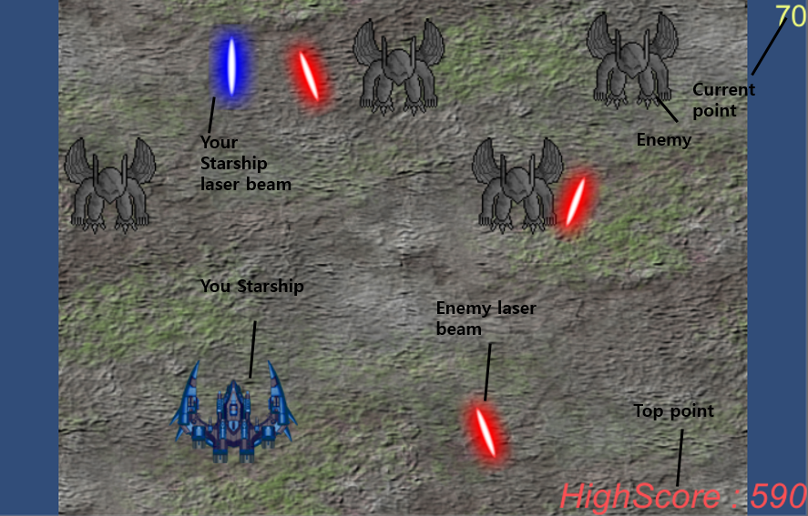

1. **Menu and Screen Descriptions**

*(Include additional screen shots and accompanying descriptions for any menus and additional screen)*

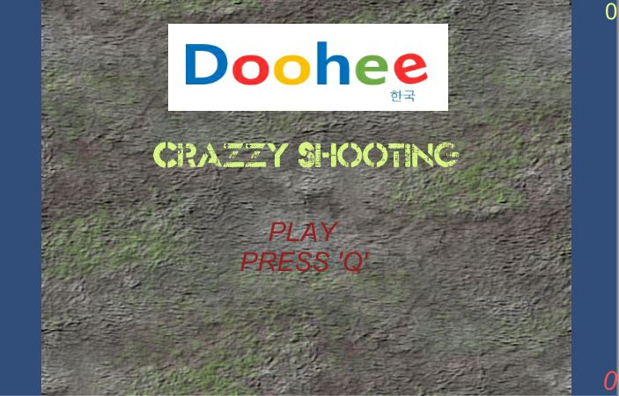

1. **Game World**

*(Describe Your Game Environment)*

Battle field in your planet

1. **Levels**

*(Describe Each of your game levels)*

*Wave 1: Many* enemies(No enemy laser beam)

*Wave 2: Some* enemies have the laser beam)

*Wave 3: Some* enemies are very strong

*Wave 4: Exist boss*

*Wave 5: Exist 2 boss*

*Wave 6: Exist 4 boss*

1. **Game Progression**

Game progression is wave 1 to wave 6 and repeat

1. **Characters**

*(Describe Your game avatar if applicable)*

*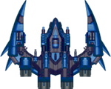Your Starship*

*Enemies*

*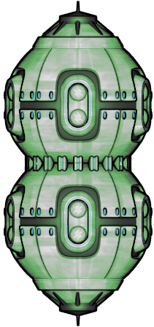Boss*

1. **Non-player Characters**

(Describe Any Computer controlled Allies and how they work)

It does not have allies

1. **Enemies**

*(Describe computer-generated enemies and boss monsters)*

*Enemies spawn from their position*

1. **Weapons**

*(Describe any weapons available to the user)*

*C:\Users\user1\Desktop\beam1.pngYour laser beam*

1. **Items**

*(Describe any in-game items that can help or hinder the user)*

No item, it is little bit hard game!

1. **Abilities**

Laser beam

1. **Vehicles**

Starship

1. **Script**

This game does not provide script

1. **Scoring**

Enemy: 10

Laser beam enemy: 50

Strong enemy: 100

Boss: 200

1. **Puzzles/Mini-games**

This game does not provide puzzles/mini-games

1. **Bonuses**

Kill the Boss!

1. **Cheat Codes**

No cheat

1. **Sound Index**

*(Include an index of all your sound clips)*

**Laser beam effect: shoot.wav**

**Explosion effect: Explosion2.wav**

**Background music: 03-main-title.mp3**

1. **Story Index**

*(Outline your game story here)*

The enemies invade your planet you have to defend your planet from six enemy waves

1. **Art / Multimedia Index**

*(Include an index of all your graphic and video assets here)*

1. **Design Notes**

*(Include additional design notes here)*

1. **Future Features**

*(Include any future features that are planned to be implemented)*

1. *Various enemies*
2. *Can choose starship*
3. *Display life of starship*